**Capstone Project**

**Store Management System**

By Shivansh Sharma

**Abstract:**

The SM, or Store Management System, is the software that will allow customers to purchase things online. "Store Management System" is abbreviated as SM. It is effective and simple to use. You must be logged in as a user or administrator to use this software. The administrator has full access to all features, whilst users have limited access. Users and administrators have their own logins in this system.

**Objectives:**

Functional Description:

**·** This system will have two types of user accounts (Admin & User)

**·** Admin can add items in list of goods with price and quantity.

**·** Admin can manage users, add user and delete user.

**·** User can purchase product and will receive a payment invoice.

The main objective of this project is to meet with the requirements of problem statement given. Administrator will have the full control of this software

**Homepage**

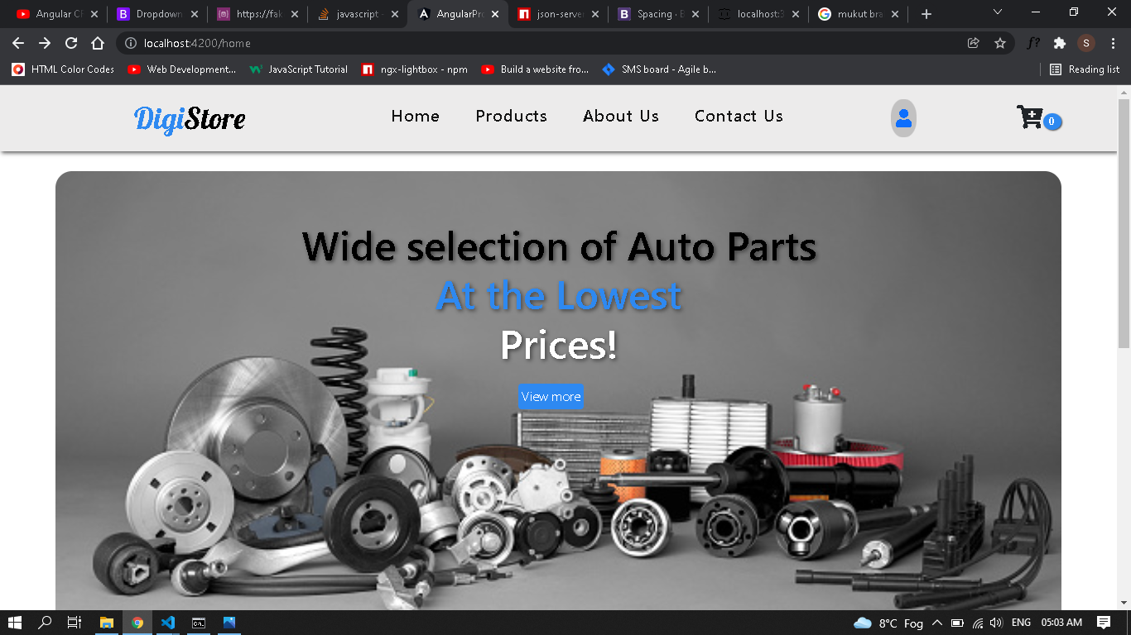

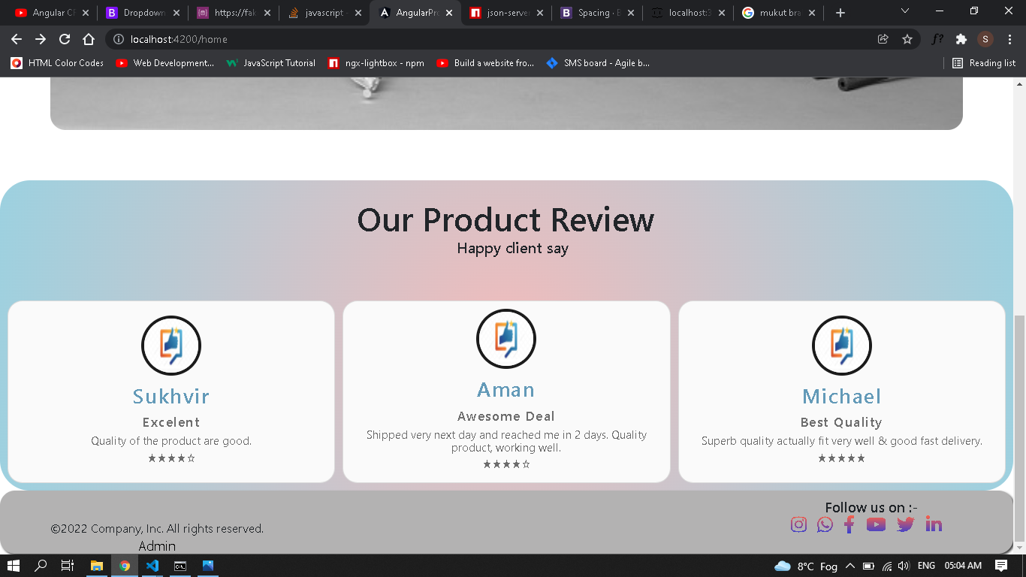

**Product Page**

In product page user can see the product card and can add to cart using add to cart button.

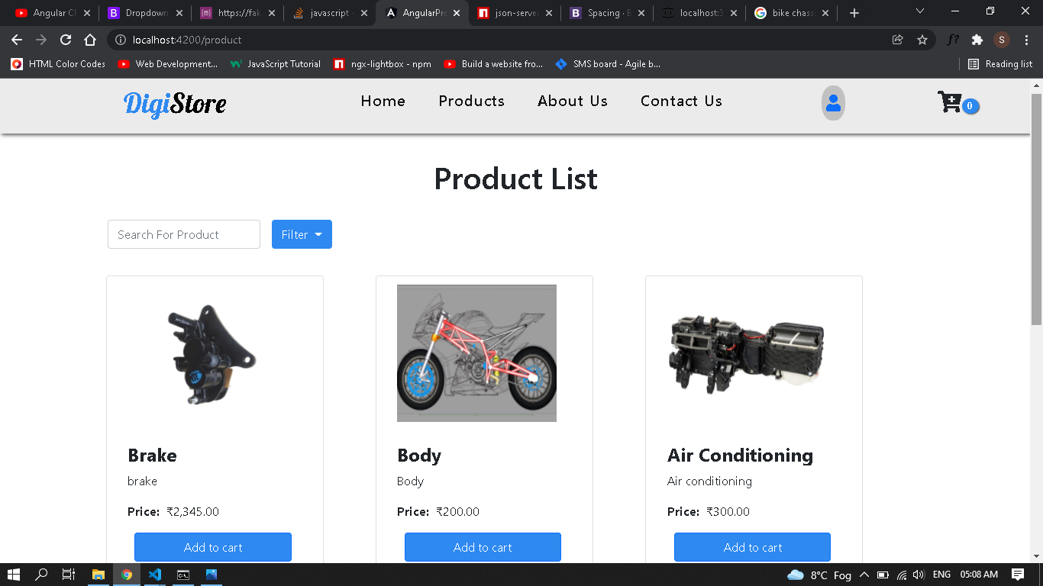

**Cart Page**

In cart page user will see below screen if no item is presented on the cart.

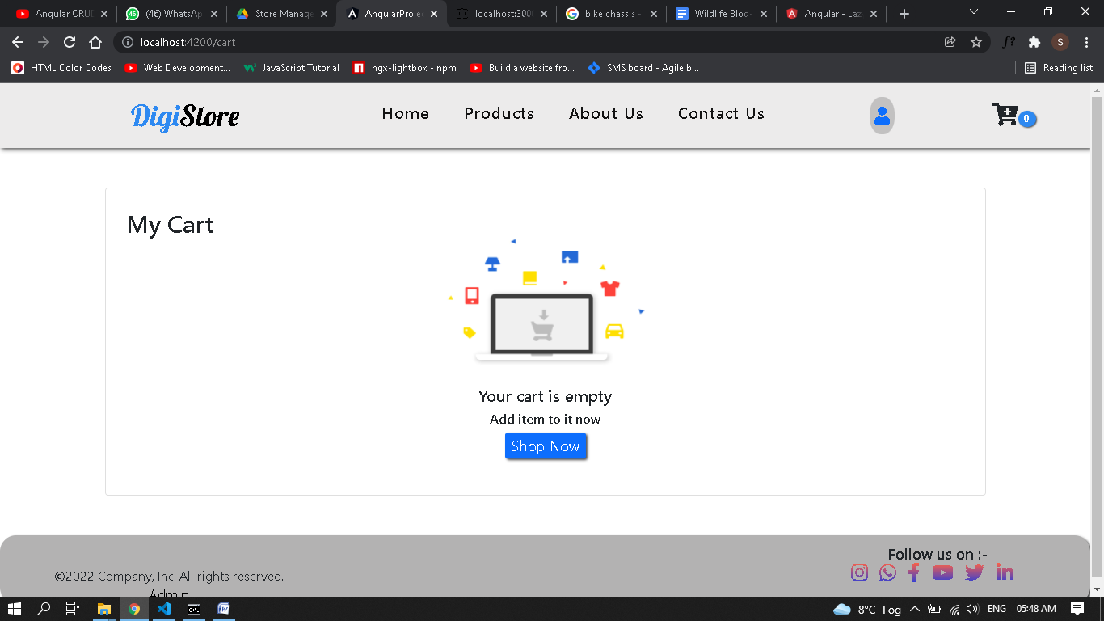

**Contact Us Page**

In contact us page user can see contact us details or they can send us there contact details for contacting them.

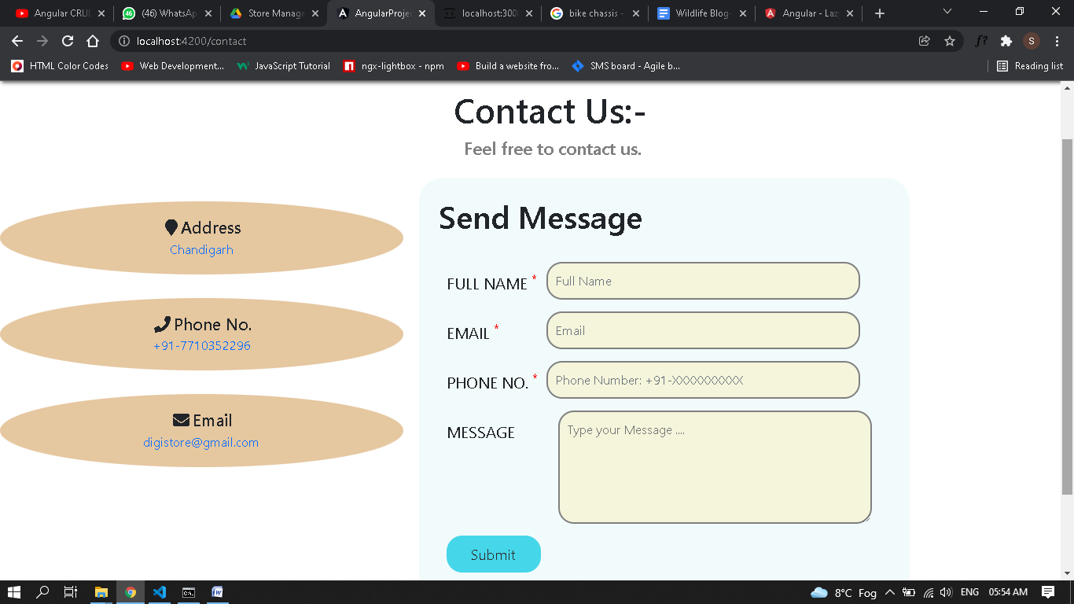

**User Login Page**

User also can log in to the website with there email id and password.

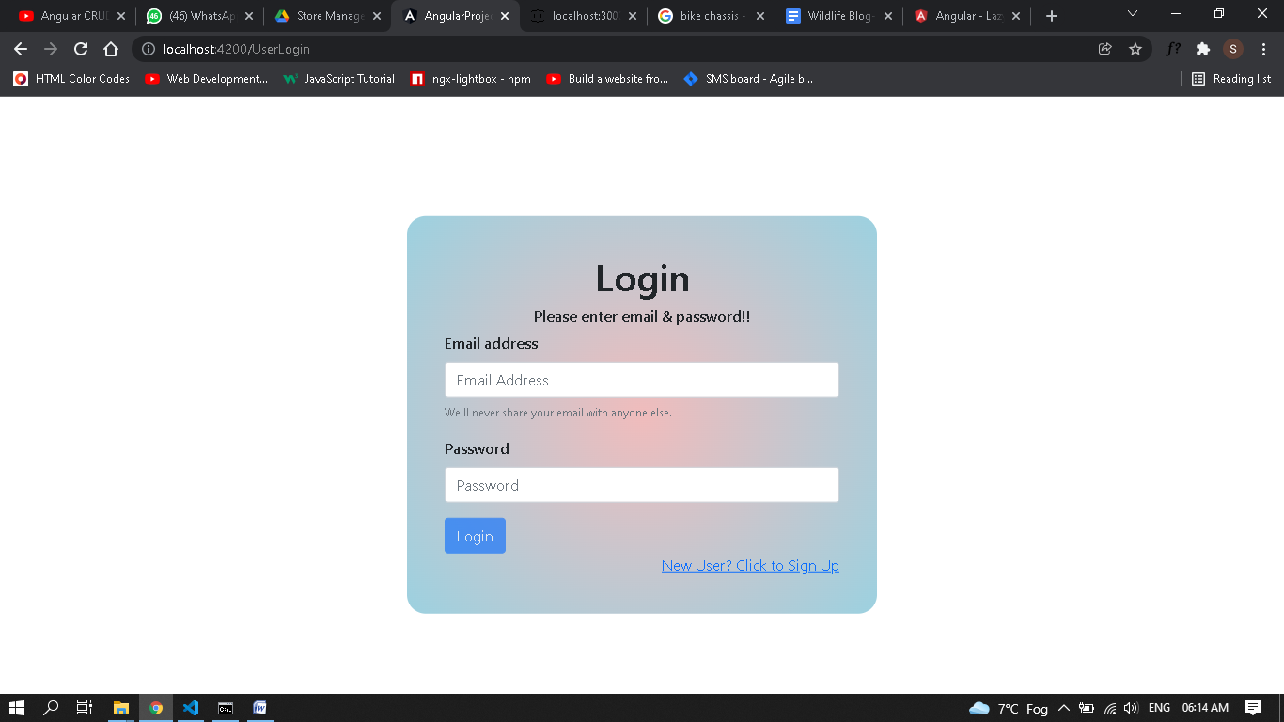

**User signup Page**

New user can sign up.

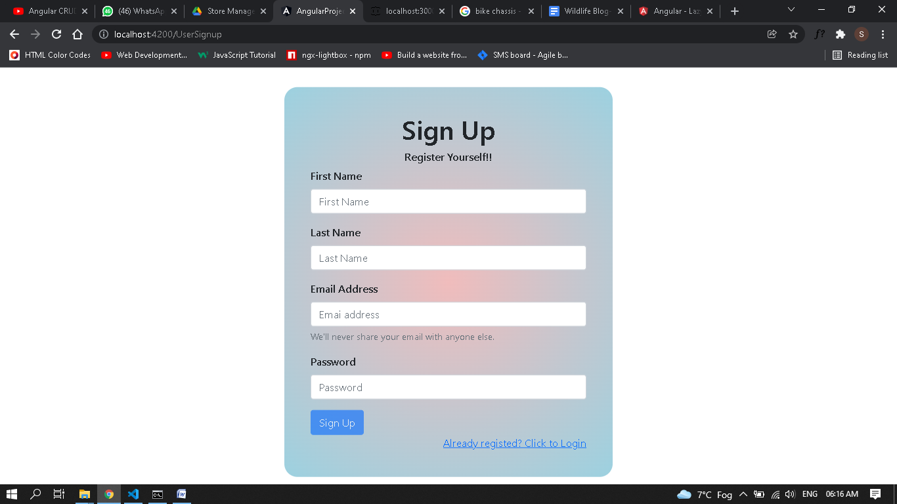

**Admin Login**

When admin wants to go to there panel first they need to login.

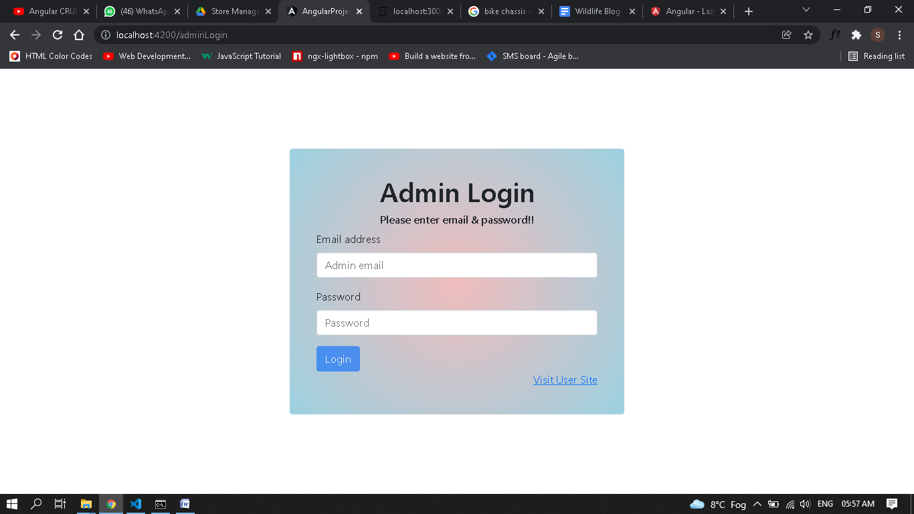

**Admin Add Product Page**

From admin page admin can add product, delete product and edit the products. 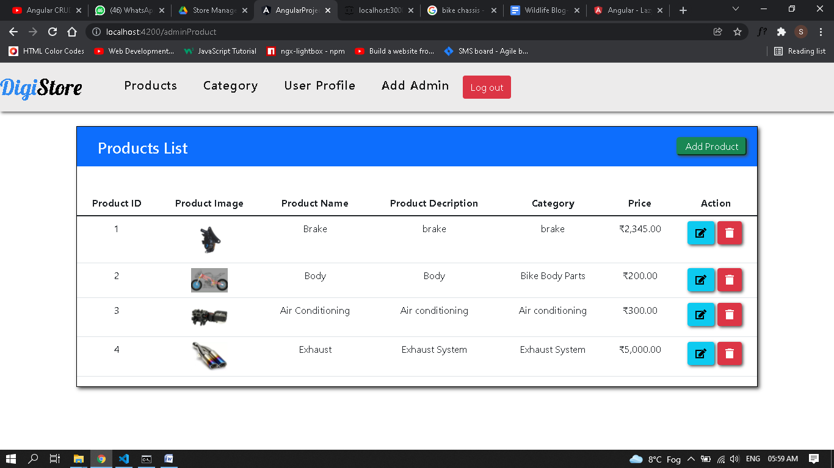

**Admin Category Page**

From admin page admin can add category, delete category and edit the category.

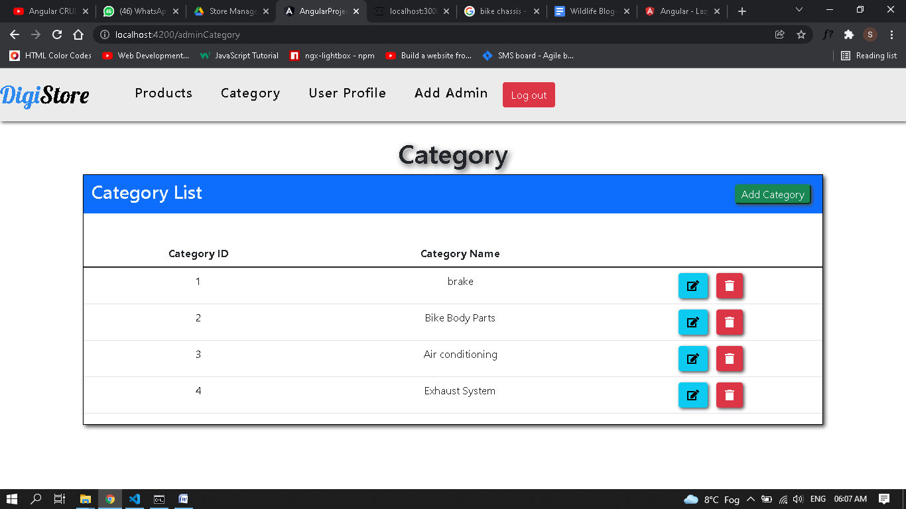

**User Profile Page**

From admin page admin can add user, delete user and edit the user id and password. 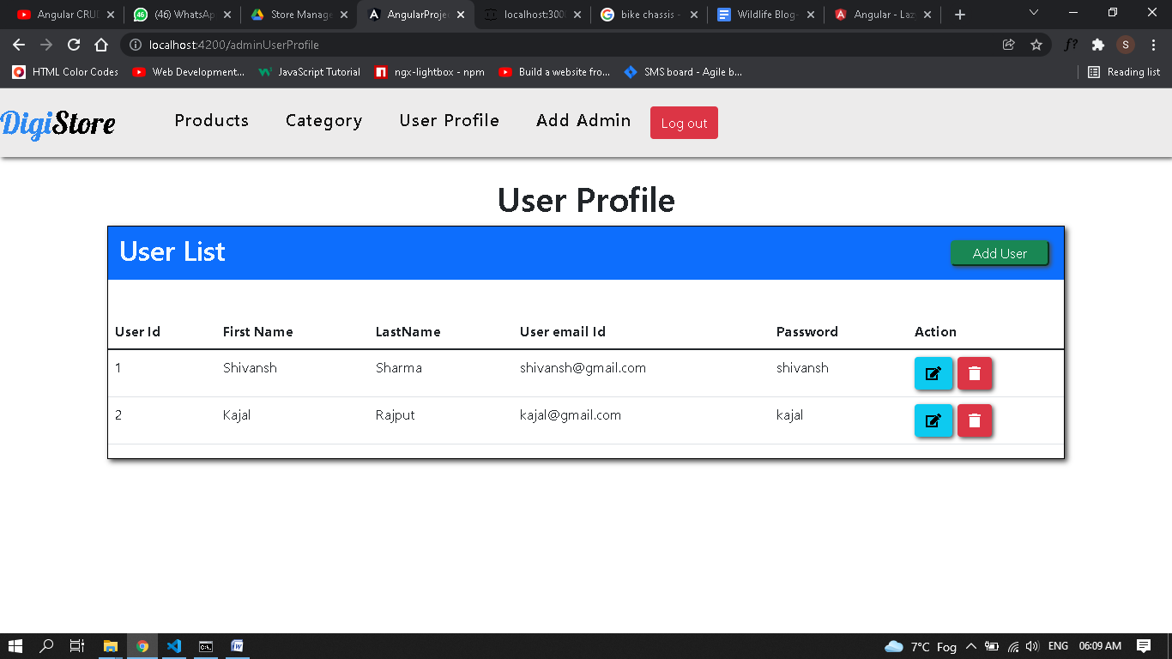

**Admin Profile Page**

From admin page admin can add another admin, delete another admin and edit/change the id and password.

